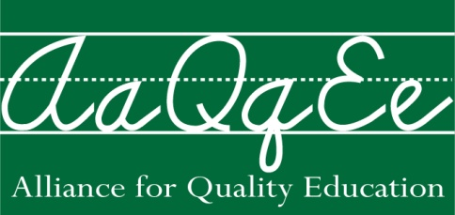

2013 School Aid Budget Fact Sheet

If Enacted by the Legislature, Executive Budget Proposal = More Classroom Cuts
The Executive Budget proposes a 4.4% school aid increase. Last year’s enacted budget included a 4% increase and the result was more classroom cuts. Over 5000 educators were cut from our schools.

The Legislature Needs to Add at Least $350 Million in Additional Funding
An additional $350 million will be needed to prevent yet another round of classroom cuts. These funds should be distributed through GEA restorations or the foundation formula. Over the past few years 35,000 educators have been cut. Thirty-one percent of school districts have made cuts to art, 33% to music, 24% have cut back on honors classes, 44% have reduced summer school, 23% have reduced career and technical education, 11% have reduced or eliminated pre-kindergarten, 57% have cut back on interscholastic sports and two-thirds have increased class sizes. [Source NYS Council of School Superintendents survey] These cuts have hurt our students and undermine their readiness to compete for college and the job market.

The Legislature Must Ensure that the $203 Million in Fiscal Stabilization Funds are Distributed Fairly and Go into Base School Aid
The Governor only proposed $322 million in classroom funding through the Gap Elimination Adjustment (GEA). He also proposed $203 million in Fiscal Stabilization Funds. These funds have not been distributed and are proposed as one-year funding. The Legislature needs to ensure these funds are fairly distributed through either GEA restorations or foundation aid. And these funds need to go into the base funding that schools get, rather than being a one-shot.

$83 Million can be Saved by Reprogramming the Performance Improvement and Management Efficiency Competitive Grants
Last year the Governor and the Legislator appropriated $50 million for these competitive grants, but only $17 million were awarded. The Executive budget proposes to expand these competitive grants to $100 million despite the fact that they were only able to award a fraction of these funds last year. The legislature should limit the appropriation to $17 million to renew existing grants and use the rest towards restoring school aid.

The Foundation Formula should be Repaired
While the foundation formula prioritizes high and average need districts, it can and should be improved.
- Last year the legislature limited the hold-harmless provision, the same should occur this year in the context of limited funds.
- The Income Wealth Index is a factor in the foundation formula that measures the relative income wealth of school districts. When calculating state aid districts that have an IWI below 65% of the state average have their wealth rounded up to 65%--this deprives many of the poorest districts in the state of their fair share of school funding.
- The demographic factors in the foundation formula have been frozen in place for several years. There is no accounting for changes in enrollment or increased poverty that resulted from the recession. Many districts are being shortchanged as a result. The data should be updated in order to make the foundation aid formula work properly

For Information Contact: Alliance for Quality Education, 94 Central Avenue, Albany, NY 12206
(518) 432-5315 x103

